Logistic Classification Report

**Data set:**

Google APIs data，there are 3670 photos belong to 5 classes.



**Training model**

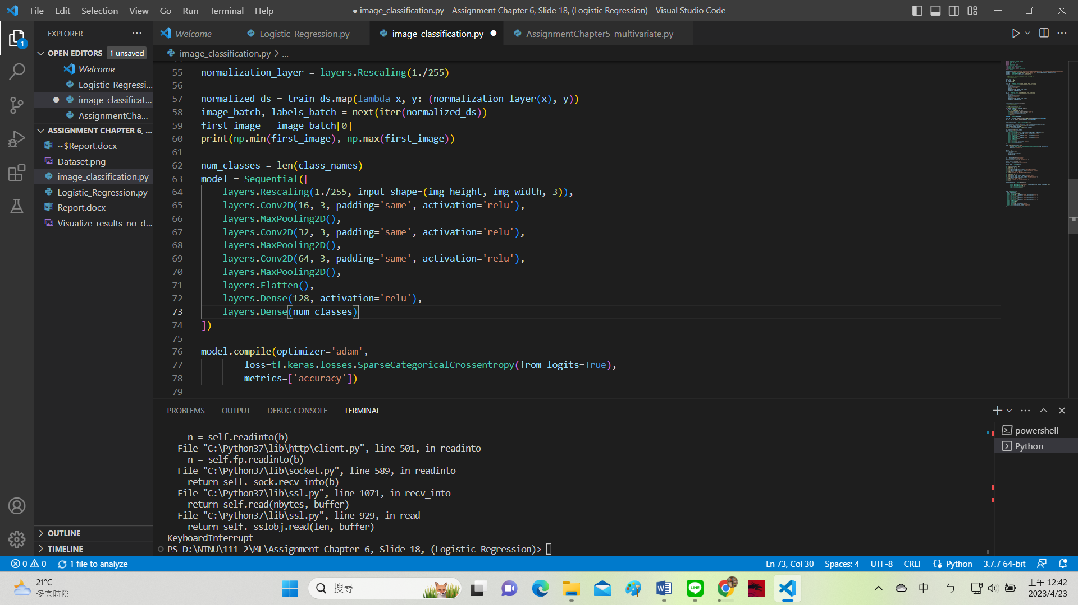

**Training results:**

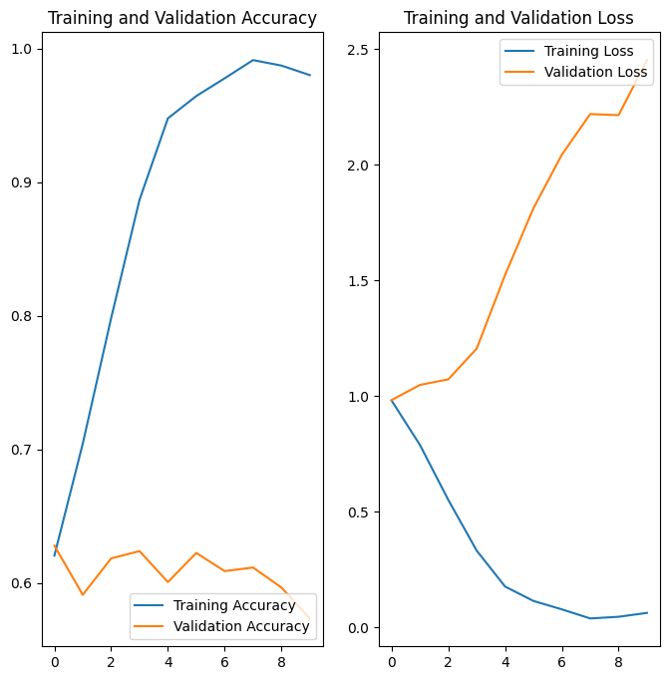

In the plots above, the training accuracy is increasing over time, whereas validation accuracy stalls around 60% in the processing. It might be overfitting.

When there are a small number of training examples, the model sometimes learns form noises or unwanted details from training examples.

I use Data augmentation and dropout to fix this problem.

**Data augmentation:**

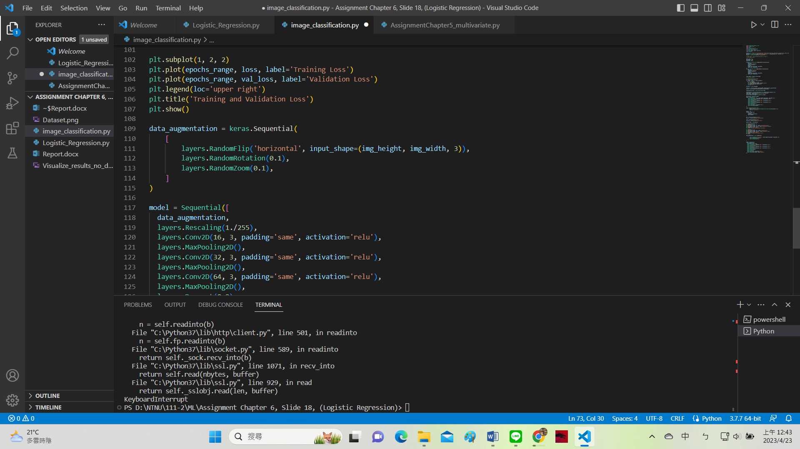



Data augmentation takes the approach of generating additional training data from your existing examples by augmenting them using random transformations that yield believable-looking images. This helps expose the model to more aspects of the data and generalize better.

**New training model:**

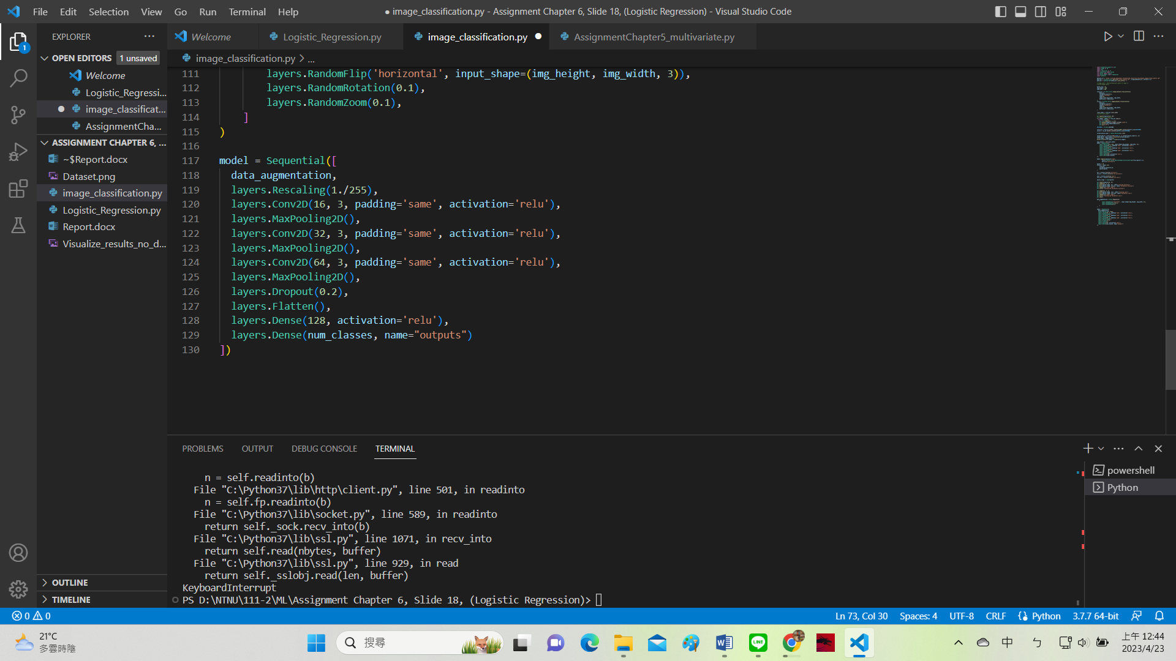

**New training results:**

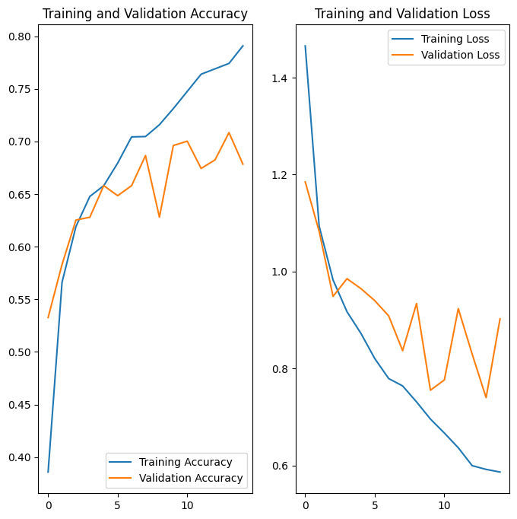

After dropout and augmentation, result is better.

**Prediction**

Test data:

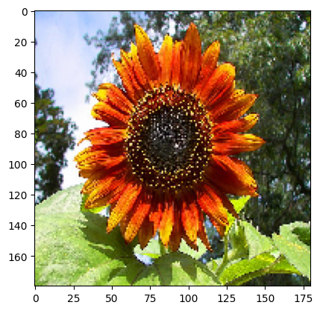

This image most likely to sunflowers with a 95.84 percent confidence. And it also showed that logistic classification can work well in the presences of moderate non- linearities.